**What's in a Name? Factors that influence the usage of Generic vs. Trade Names for Cardiac Medications among Healthcare Providers**

David Ouyang MD1, Rebecca Tisdale MD2, Paul Cheng MD PhD1, Jeffrey Chi MD2, Jonathan H. Chen MD PhD2,Euan Ashley MBBS PhD1,

1Department of Internal Medicine, Division of Cardiovascular Medicine, Stanford University School of Medicine, Stanford, CA USA

2Department of Internal Medicine, Division of Hospital Medicine, Stanford University School of Medicine, Stanford, CA USA

Word Count: 799

**Author Contributions:** Ouyang had full access to the data in the study and takes responsibility for the integrity of the data and the accuracy of the data analysis.

*Study concept and design*: Ouyang, Tisdale, Cheng, Chen, Ashley

*Acquisition of data*: Ouyang, Chi, Chen.

*Analysis and interpretation of data*: Ouyang, Tisdale, Ashley, Chi, Chen.

*Drafting of the manuscript*: Ouyang, Tisdale, Cheng, Chen, Ashley

*Critical revision of the manuscript for important intellectual content*: Ouyang, Tisdale, Cheng, Chi, Chen, Ashley

*Statistical analysis*: Ouyang, Tisdale, Chen.

**Introduction:**

The use of trade names for drugs in clinical practice raises awareness of these brand names and has been shown to increase their use1. While academic medical centers have made an effort to teach generic medication names and discourages the use of trade names to reduce bias and contain costs, usage of trade names persists. Variation in trade name usage has been thought to be related to novelty of medication, pharmaceutical advertising budget, differences in pronounceability between genetic and trade names, and familiarity of medications2. We previously showed analysis of text paging behaviors provides a reflection of real-world provider-to-provider communication outside of formal documentation and can highlight bias in the use of medication names3. In this analysis, we appliedanalyzing todemonstratein cardiology and its lack of association with novelty of medication, medication cost, or linguistic differences between names.

**Methods:**

We analyzed 1,048,576 text pages to housestaff between June 1, 2013 and April 24, 2017 at an academic university hospital. Mentions of the most frequently used medications in cardiology were identified and tallied. When explicitly mentioned in the body of the text page, the profession of the sender was established. Common misspellings and alternative spellings were identified by regular expression and included in the analysis. Average wholesale price of medications were pulled from Micromedex’s RED BOOK online. Text pages were algorithmically processed using Python and analysis was performed in R and the packages ggplot2, ggthemes, scales, and plyr. Complete code for the data visualization is available at https://github.com/douyang/PagingDataAnalysis.

**Results and Data Visualization:**

We identified 102,243 pages regarding medications, of which 34,489 (33.7%) pages were from nurses and 20,446 (20.0%) pages were from pharmacists. Forty-seven commonly used cardiac medications were mentioned a total of 26,463 times. The most common classes of medications were anti-arrhythmics (14.6%), angiotensin-converting-enzyme inhibitors (14.6%), and beta blockers (12.5%). There was significant variation in the use of trade names vs. generic names (Figure 1).

We created a five-part data visualization to display the variation in the use of generic and brand names for medications across provider types and its correlation with average wholesale price, FDA approval date, whether the medication was on patent, difference in the number of syllables between trade name and generic name, and the frequency of mention. The focal point of our data visualization is in the center, with a plot of the ratio of generic to trade name mentions. A point estimate and 95% confidence interval line is used to represent total mentions, while mentions that can be attributed to either a pharmacist or a nurse are independently analyzed and the ratio denoted by a P or a N respectively. Medications on patent are denoted by red, while medications no longer on patent are black. For example, furosemide is a commonly mentioned off-patent medication and the ratio of mentions for "Lasix" to "furosemide" is 17.4 and is denoted by a black point estimate in the bottom right of the central figure. Of the text pages from nurses and pharmacists, the ratios are 3 and 42.5 and the point estimates are denoted by "P" or "N" respectively to the left and right.

Using the same y-axis, to either side of the center figure we display the relationship between each medication and the year of FDA approval, the difference in number of syllables between generic and trade names, the frequency of mention, and the average unit price. We show the relationship between each medication and difference in number of syllables between generic and trade names using an arrow, with the head of the arrow identifies the number of syllables in the trade name and the back of the arrow identifies the number of syllables in the generic name. The length of the arrow is the difference in the number of syllables between trade and generic name.

**Conclusions:**

In our study, we use a high throughput method of analyzing and visualizing healthcare worker sentiment towards medications. From our data visualization, we see that there is significant variation in the preference of trade names vs. generics names across drug classes and healthcare providers. This variation did not visually correlate with the year of FDA approval, the number of syllables in the trade name or brand name, frequency of mention, average unit price, or whether the drug is on patent. Nurses are more likely to use trade names than pharmacists. Physicians do not usually self-identify their role in the text page, thus we were unable to independently assess their behavior. To the extent that text pages reflect other modes of communication and prescribing patterns, the patterns of name use suggest that further interventions to promote the use of generic names and limit bias in medicine are needed.

Figure 1

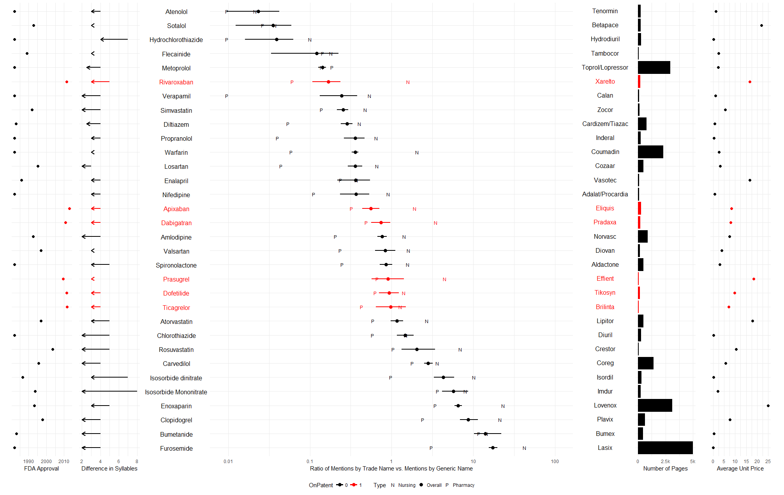



Bibliography

1. Mott DA, Cline RR. Exploring generic drug use behavior: the role of prescribers and pharmacists in the opportunity for generic drug use and generic substitution.*Med Care*. 2002;40(8):662-674. doi:10.1097/01.MLR.0000020926.85284.8E.

2. Sierles FS, Brodkey AC, Cleary LM, et al. Medical students’ exposure to and attitudes about drug company interactions: a national survey. *JAMA*. 2005;294(9):1034-1042. doi:10.1001/jama.294.9.1034.

3. Ouyang D, Tisdale R, Ashley EA, Chi J, Chen JH. Acetaminophen or Tylenol? A Retrospective Analysis of Medication Digital Communication Practices. *J Gen Intern Med.* 2018; doi:10.1007/s11606-018-4455-1

4. Choudhry NK, Denberg TD, Qaseem A. Improving adherence to therapy and clinical outcomes while containing costs: opportunities from the greater use of generic medications: best practice advice from the Clinical Guidelines Committee of the American College of Physicians. *Ann Intern Med*. 2016;164:41–49. doi: 10.7326/M14-2427